WORD GUESSER

UNais yousha siddiqui 18k-0241

nabia 18k-0144

Section : h

2018

**INTRODUCTION:**

* This game is a 2 players game.
* The players will give each other a word which they need to guess.
* Players will also provide a hint.
* They will have 5 lives for every single word to guess.
* If their lives get over a beep sound will show that they lost.
* A point will be awarded to other player if player one can’t guess the word.
* After 5 words of each player the game will announce the winner.
* High score will be saved in a file.
* Instructions will be provided.

MODULES

Main:

It just changes the color of the display screen and calls the 2 modules in it which are Main menu and Play menu.

1. Main menu:

Main menu displays the options that a user can select by pressing the respective number.

1. Play menu:

It works with the users preferred option and calls the function basically it’s the main body of the whole game.

1. Instructions:

It reads the instructions from the file and displays it on the console screen. It works when user press to open instructions.

1. High score:

It reads the high score from a file and displays it on the console screen. It works when a user press to open high scores.

1. Names:

It asks for the name of the players and stores it in global variables. It is called in the main game.

1. Screen:

It is the main game screen which shows the player names, scores. And it is the same screen on which the players play game.

1. Question_P1:

It is the function which asks the player 1 to give a word and a hint to the other player to guess.

1. Answer_P2:

It displays the hint given by the player 1 and lives left to find the word it also plays sound if the persons guess the correct or wrong word and it also plays a sound if the player cannot guess a word.

1. Question_P2:

It is the function which asks the player 1 to give a word and a hint to the other player to guess.

1. Answer_P1:

It displays the hint given by the player 1 and lives left to find the word it also plays sound if the persons guess the correct or wrong word and it also plays a sound if the player cannot guess a word.

1. Win_lose:

It calculates the scores and determines the winner and also includes the scores in a file and display the highest score and it also plays a sound while announcing the winner.

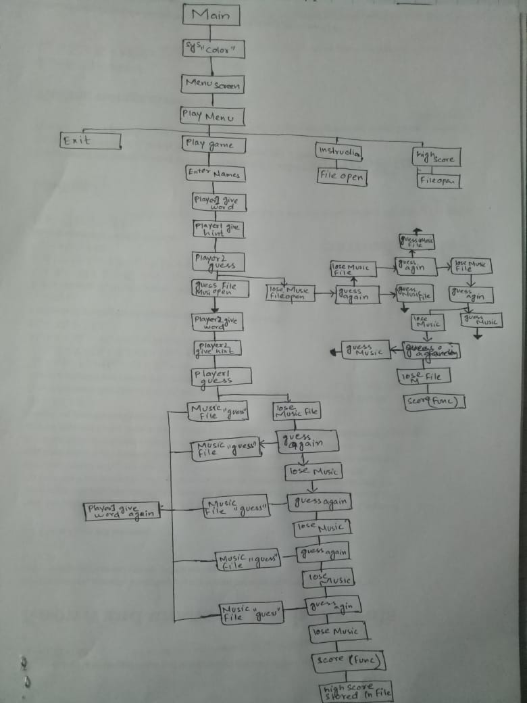

SOURCE CODE

#include <stdio.h>

#include <stdlib.h>

#include <string.h>

#include <conio.h>

#include <windows.h>

#include <MMsystem.h>

// FUNCTIONS PROTOTYPE

void Menuscreen ();

int Playmenu ();

void screen ();

int instructions ();

int highscore ();

void names ();

void Question_P1();

void Answer_P1();

void Question_P2 ();

void Answer_P2 ();

void win_lose ();

//

// VARIABLES DESCRIBED GLOBALLY

char player1[10],player2[10],hint[100],word[50],answer[50],instruction[80],ch;

int i=1,score1=0,score2=0,choice,j=1,len1,len2;

//

int main()

{

system("color 3F");// SCREEN COLOR

Menuscreen ();

Playmenu ();

}

// MAIN MENU SCREEN

void Menuscreen ()

{

printf("\n\n\t\t\t\tWORD");

printf("\n");

printf("\t\t\t\t GUESSER");

printf("\n\n\n\n\n\n\n\n\n\t\t\t\tPress : \n");

printf("\n\n\t\t\t\t1) PLAY \n");

printf("\n\t\t\t\t2) EXIT \n");

printf("\n\t\t\t\t3) HOW TO PLAY\n");

printf("\n\t\t\t\t4) HIGH SCORE\n");

printf("\n\t\t\t\t\t\t\t BY: UNAIS AND NABIA\n");

scanf("%d",&choice);// CHOOSING WHICH OPERATION TO PERFORM

system ("cls");

}

// PROCEEDS PROGRAM WITH USER DIRECTION

int Playmenu ()

{

if (choice>=1 && choice<=4)

{

switch (choice)

{

case (1):

names ();

while (j!=6)

{

screen ();

Question_P1();

screen ();

Answer_P1();

screen ();

Question_P2 ();

screen ();

Answer_P2 ();

j++;

}

win_lose ();

break;

case (2):

printf("\n\n\n\n\t\t\t PRESS ANY KEY TO EXIT\n\n\n\n\n");

return 0;

break;

case (3):

instructions ();// READ FROM A FILE

getch ();

break;

case (4):

highscore ();// READ FROM A FILE

getch ();

break;

}

}

}

int instructions ()

{

printf("\n\n\t\t\t\tINSTRUCTIONS\n\n");

// FILE CREATED

FILE *fp = fopen ("C:\\Users\\UNIAS\\Desktop\\MAIN PROJECT\\text\\Instructions.txt","r");

if (fp == NULL)

{

printf("UNABLE TO FIND THE FILE");

return 0;

}

while (1)

{

fgets(instruction,"%s",fp);// READ ALL THE INFORMATION FROM FILE

printf("\n%s",instruction);

if (feof(fp))

break;

}

fclose (fp);

}

int highscore ()

{

char name[80];

int score;

system("cls");

printf("\n\n\t\t\t\tHIGH SCORE\n\n");

// FILE CREATED

FILE *fp = fopen ("C:\\Users\\UNIAS\\Desktop\\MAIN PROJECT\\text\\highscore.txt","r");

if (fp == NULL)

{

printf("UNABLE TO FIND THE FILE");

return 0;

}

while (1)

{

// READING THE NAME AND SCORE

fscanf(fp," %[^,],%d",name,&score);

printf("\n\n%s\t:\t%d",name,score);

if (feof(fp))

break;

}

fclose (fp);

}

// FUNCTION CALLED IN PLAY (ASKING FOR NAMES OF PLAYERS)

void names()

{

system("cls");

printf("\n\n\t\t\t\tPLAYER NAMES\n\n\n");

printf("!!!Enter Names In Capital!!!\n\n");

printf("Enter Name Of Player1 : ");

scanf("%s",player1);

printf("\n\nEnter Name Of Player2 : ");

scanf("%s",player2);

}

// GAME SCREEN WHILE PLAYING

void screen()

{

system("cls");

printf("\t\t\t\t WORD");

printf("\n\t\t\t\t GUESSER");

printf("\n\n\t\t\t\t%s:%s",player1,player2);

printf("\n\t\t\t\t %d:%d",score1,score2);

for (i=1;i<8;i++)

{

printf("\n");

}

}

// WORD GIVEN BY PLAYER 1

void Question_P1()

{

printf("\t\t\t\t%s GIVE WORD\n",player1);

printf("\n\nENTER WORD : ");

scanf(" %[^\n]",word);

len1 = strlen(word);

printf("\nENTER HINT : ");

scanf(" %[^\n]",hint);

}

// ANSWER BY PLAYER 2

void Answer_P1()

{

int lives=4;

for(i=1;i<=5;i++)

{

printf("\t\t\t\t%s GUESS WORD",player2);

printf("\t\t LIVES : %d",lives);

printf("\n\n\t\t\t\t LETTERS : %d",len1);

printf("\n\nHINT : %s",hint);

printf("\n_________");

printf("\n\n\nGUESS WORD : ");

scanf(" %[^\n]",&answer);

if((strcmp(word,answer)) == 0)

{

printf("\n\n\t\t\t\t!!CORRECT CONGRATULATIONS!!\n\n");

// SOUND

PlaySound(TEXT("C:\\Users\\UNIAS\\Desktop\\MAIN PROJECT\\music\\correct.wav"),NULL,SND_SYNC);

break;

}

if (i<=4)

{

lives--;// LIVES DECREASING WITH EVERY WRONG ANSWER

printf("\n\n\t\t\t\t!!WRONG TRY AGAIN!!\n\n");

// SOUND

PlaySound(TEXT("C:\\Users\\UNIAS\\Desktop\\MAIN PROJECT\\music\\wrong.wav"),NULL,SND_SYNC);

}

if (i == 5)

{

printf("\n\n\t\t\t\t!!YOU LOSE!!");

// SOUND

PlaySound(TEXT("C:\\Users\\UNIAS\\Desktop\\MAIN PROJECT\\music\\lose.wav"),NULL,SND_SYNC);

// AWARDING SCORE TO PLAYER 1 BECAUSE PLAYER 2 CAN'T GUESS A WORD IN RESPECTIVE LIVES

score1++;

}

}

sleep(1);

}

// QUESTION BY PLAYER 2

void Question_P2 ()

{

printf("\t\t\t\t%s GIVE WORD\n",player2);

printf("\n\nENTER WORD : ");

scanf(" %[^\n]",word);

len2 = strlen (word);

printf("\nENTER HINT : ");

scanf(" %[^\n]",hint);

}

// ANSWER BY PLAYER 1

void Answer_P2()

{

int lives=4;

for(i=1;i<=5;i++)

{

printf("\t\t\t\t%s GUESS WORD",player1);

printf("\t\t LIVES : %d",lives);

printf("\n\n\t\t\t\t LETTERS : %d",len2);

printf("\n\nHINT : %s",hint);

printf("\n_________");

printf("\n\n\nGUESS WORD : ");

scanf(" %[^\n]",&answer);

if((strcmp(word,answer)) == 0)

{

printf("\n\n\t\t\t\t!!CORRECT CONGRATULATIONS!!\n\n");

// SOUND

PlaySound(TEXT("C:\\Users\\UNIAS\\Desktop\\MAIN PROJECT\\music\\correct.wav"),NULL,SND_SYNC);

break;

}

if (i<=4)

{

lives--;// LIVES DECREASING WITH EVERY WRONG ANSWER

printf("\n\n\t\t\t\t!!WRONG TRY AGAIN!!\n\n");

// SOUND

PlaySound(TEXT("C:\\Users\\UNIAS\\Desktop\\MAIN PROJECT\\music\\wrong.wav"),NULL,SND_SYNC);

}

if (i == 5)

{

printf("\n\n\t\t\t\t!!YOU LOSE!!");

// SOUND

PlaySound(TEXT("C:\\Users\\UNIAS\\Desktop\\MAIN PROJECT\\music\\lose.wav"),NULL,SND_SYNC);

// AWARDING SCORE TO PLAYER 1 BECAUSE PLAYER 2 CAN'T GUESS A WORD IN RESPECTIVE LIVES

score2++;

}

}

sleep(1);

}

// DECIDING WINNER AND STORING HIGH SCORE IN FILE

void win_lose ()

{

int score;

char name[10];

if (score1 > score2)

{

system("cls");

printf("\n\n\n\n\n\n\n\n\t\t\t !!!%s IS THE WINNER!!!",player1);

// SOUND

PlaySound(TEXT("C:\\Users\\UNIAS\\Desktop\\MAIN PROJECT\\music\\win.wav"),NULL,SND_SYNC);

// READING FROM FILE

FILE *fa = fopen ("C:\\Users\\UNIAS\\Desktop\\MAIN PROJECT\\text\\highscore.txt","r");

fscanf(fa," %[^,],%d",name,&score);

fclose (fa);

FILE *fb = fopen ("C:\\Users\\UNIAS\\Desktop\\MAIN PROJECT\\text\\highscore.txt","w");

if (score < score1)

{

fprintf(fb,"%s,%d",player1,score1);

}

else if (score > score1)

{

fprintf(fb,"%s,%d",name,score);

}

else if (score == score1)

{

fprintf(fb,"%s,%d\n",name,score);

fprintf(fb,"%s,%d",player1,score1);

}

fclose (fb);

}

else if (score1 < score2)

{

system("cls");

printf("\n\n\n\n\n\n\n\n\t\t\t !!!%s IS THE WINNER!!!",player2);

PlaySound(TEXT("C:\\Users\\UNIAS\\Desktop\\MAIN PROJECT\\music\\win.wav"),NULL,SND_SYNC);

FILE *fc = fopen ("C:\\Users\\UNIAS\\Desktop\\MAIN PROJECT\\text\\highscore.txt","r");

fscanf(fc," %[^,],%d",name,&score);

fclose (fc);

FILE *fd = fopen ("C:\\Users\\UNIAS\\Desktop\\MAIN PROJECT\\text\\highscore.txt","w");

if (score < score2)

{

fprintf(fd,"%s,%d",player2,score2);

}

else if (score > score2)

{

fprintf(fd,"%s,%d",name,score);

}

else if (score == score2)

{

fprintf(fd,"%s,%d\n",name,score);

fprintf(fd,"%s,%d",player2,score2);

}

fclose (fd);

}

else if (score1 == score2)

{

system("cls");

printf("\n\n\n\n\n\n\n\n\t\t\t !!!IT'S A DRAW!!!");

PlaySound(TEXT("C:\\Users\\UNIAS\\Desktop\\MAIN PROJECT\\music\\win.wav"),NULL,SND_SYNC);

FILE *fe = fopen ("C:\\Users\\UNIAS\\Desktop\\MAIN PROJECT\\text\\highscore.txt","r");

fscanf(fe," %[^,],%d",name,&score);

fclose (fe);

FILE *fg = fopen ("C:\\Users\\UNIAS\\Desktop\\MAIN PROJECT\\text\\highscore.txt","w");

if (score < score1)

{

fprintf(fg,"%s,%d\n",player1,score1);

fprintf(fg,"%s,%d",player2,score2);

}

else if (score > score1)

{

fprintf(fg,"%s,%d",name,score);

}

else if (score == score1)

{

fprintf(fg,"%s,%d\n",name,score);

fprintf(fg,"%s,%d\n",player1,score1);

fprintf(fg,"%s,%d",player2,score2);

}

fclose (fg);

}

}

REFERENCES

* Course books
* Udemy Tutorials
* Internet websites (GeeksforGeeks, Stack overflow)